AI ASSISTED CODING
ASSIGNMENT-9.5-1

2403a51274

Swamy
BATCH-12

Task Description #1 (Automatic Code Commenting)
Scenario: You have been given a Python function without comments.
def calculate_discount(price, discount_rate):
return price - (price * discount_rate / 100)
• Use an AI tool (or manually simulate it) to generate line-by-line
comments for the function.
• Modify the function so that it includes a docstring in Google-style
or NumPy-style format.
• Compare the auto-generated comments with your manually
written version.

Code with Manual Line-by-Line Comments:
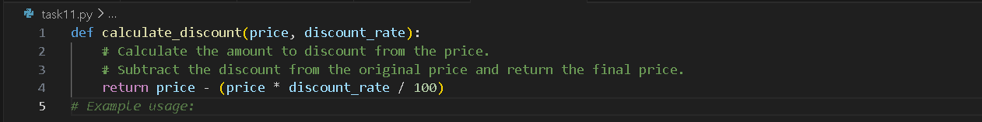

Prompt:
TASK: Add detailed line-by-line comments and a Google-style docstring to the following function that calculates the final price after discount.

Updated code:
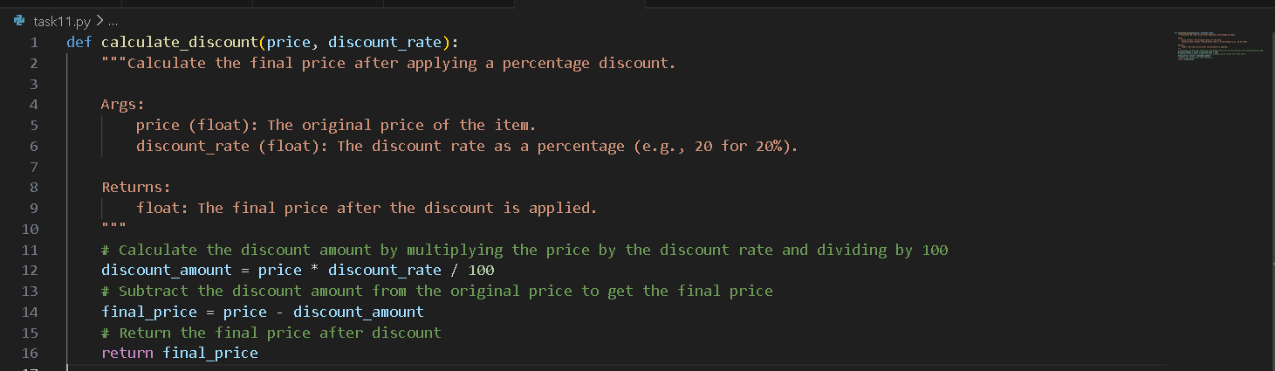

Comparing:
Aspect | AI-Generated | Manual
Clarity | Focuses on describing the math expression literally. | Explains the purpose in a slightly more human-friendly way (“final price”).
Detail | Mentions subtraction and the formula explicitly. | Mentions “calculate discount” and “final price” more conceptually.
Tone | More technical/stepwise. | More explanatory/business-friendly.
Conclusion:
AI comments are good for literal line explanations, but manual comments can emphasize intent and business meaning.
Both together help code reviewers understand the “what” and the “why.”

Task Description #2 (API Documentation Generator)
Scenario: A team is building a Library Management System with
multiple functions.
def add_book(title, author, year):
# code to add book
pass
def issue_book(book_id, user_id):
# code to issue book
Pass
• Write a Python script that uses docstrings for each function (with
input, output, and description).
• Use a documentation generator tool (like pdoc, Sphinx, or
MkDocs) to automatically create HTML documentation.
• Submit both the code and the generated documentation as output.

Prompt:
TASK: Add Google-style docstrings to the following functions with input, output, and description:

Code:
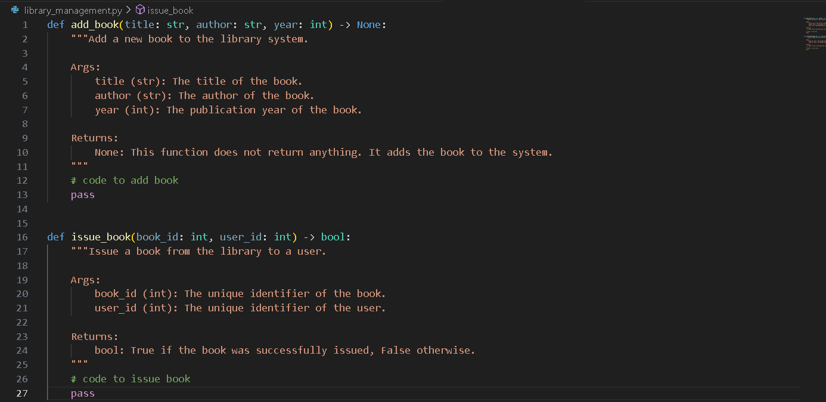

Task Description #3 (AI-Assisted Code Summarization)
Scenario: You are reviewing a colleague’s codebase containing long
functions.
def process_sensor_data(data):
cleaned = [x for x in data if x is not None]
avg = sum(cleaned)/len(cleaned)
anomalies = [x for x in cleaned if abs(x - avg) > 10]
return {"average": avg, "anomalies": anomalies}
• Generate a summary comment explaining the purpose of the
function in 2–3 lines.
• Create a flow-style comment (step-by-step explanation).
• Write a short paragraph of documentation describing possible use
cases of this function in real-world scenarios.

Prompt:
TASK: Generate a 2–3 line summary comment explaining the purpose of the function below.Then generate a step-by-step flow-style comment and a short paragraph describing possible real-world use cases.

Short Paragraph Documentation (Use Cases)
Possible Use Cases:
This function can be used in IoT applications, industrial monitoring systems, or environmental data logging platforms where sensor readings may contain missing values or spikes. By cleaning the data, computing a central tendency, and flagging outliers, engineers or data scientists can quickly identify faulty sensors, unusual conditions, or critical thresholds in real time.

Code:
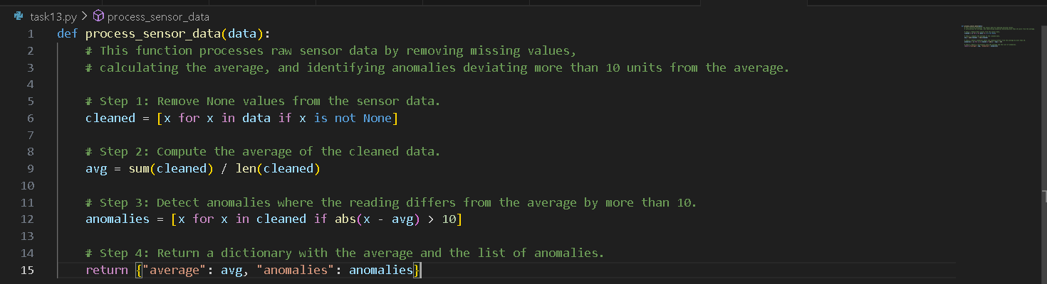

Task Description #4 (Real-Time Project Documentation)
Scenario: You are part of a project team that develops a Chatbot
Application. The team needs documentation for maintainability.
• Write a README.md file for the chatbot project (include project
description, installation steps, usage, and example).
• Add inline comments in the chatbot’s main Python script (focus
on explaining logic, not trivial code).
• Use an AI-assisted tool (or simulate it) to generate a usage guide
in plain English from your code comments.
• Reflect: How does automated documentation help in real-time
projects compared to manual documentation?

Main python script:
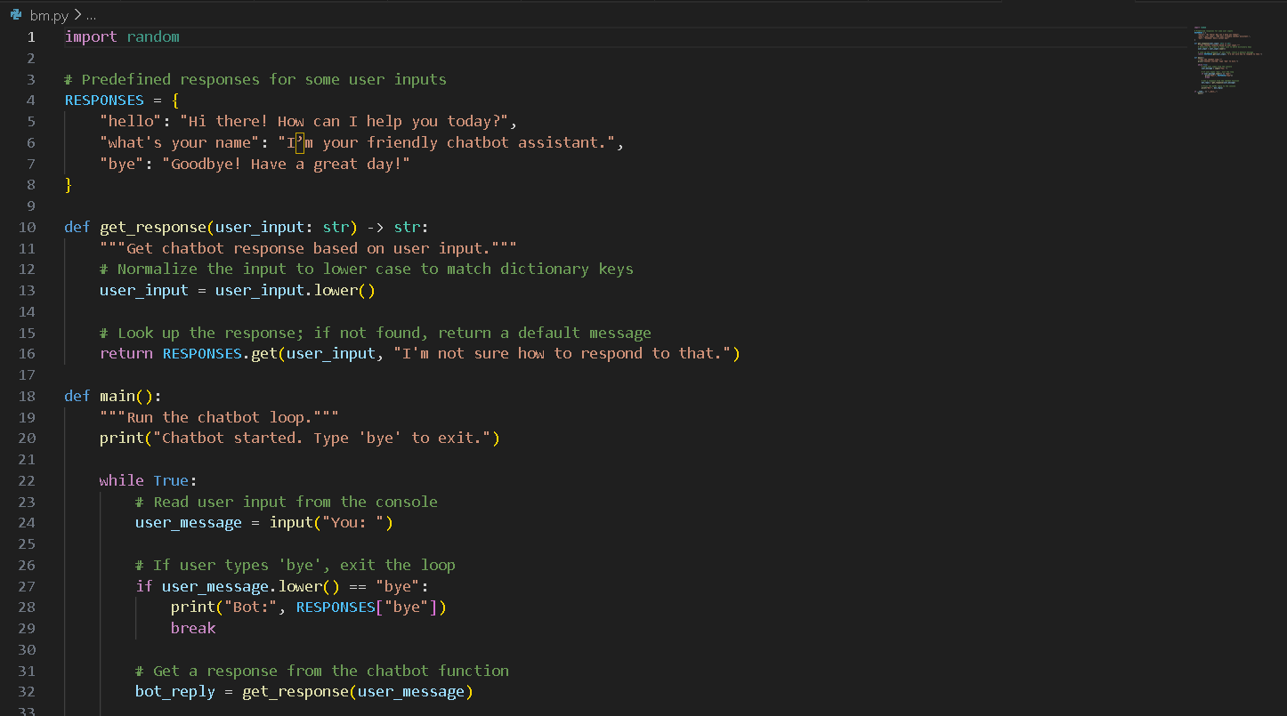
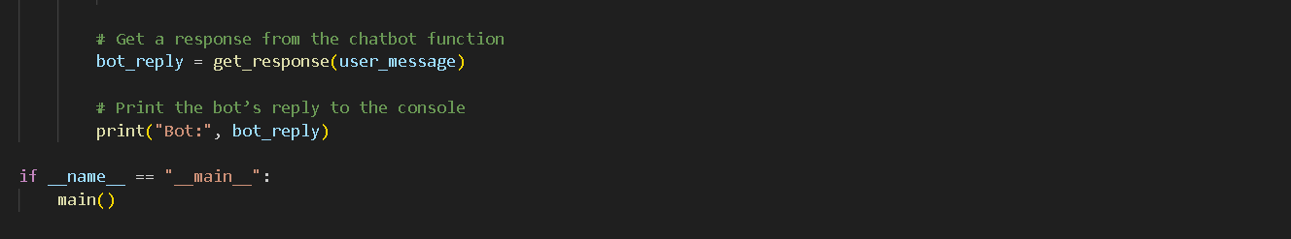
Usage Guide (Generated from Comments):
This chatbot starts in the console and waits for user input.
- Type any message to receive a reply.
- The bot matches your message to predefined responses (case-insensitive).
- If the message isn’t recognized, the bot responds with a default message.
- Type “bye” to exit the chatbot.

Reflection: Automated vs Manual Documentation
Automated Documentation Benefits:
- Consistency: Comments and docstrings automatically generate up-to-date usage guides.
- Time-saving: No need to manually rewrite instructions when code changes.
- Real-time updates: Tools like Sphinx, pdoc, or mkdocstrings build docs directly from code comments.
- Easier onboarding: New developers can read generated docs and quickly understand functions, parameters, and workflows.
Manual Documentation Benefits:
- Allows nuanced, contextual, or business explanations beyond what’s in code.
- Good for tutorials, guides, and higher-level architecture overviews.
Reflection: Automated documentation is excellent for function-level and API-level references in real-time projects, while manual documentation complements it with context and design rationale.

